**My Online Shopping Site**

We have a physical shopping store, which is doing well. We want to increase the business by extending the availability of our products through online mechanisms.

Quick time –to- market is the main criteria, we are adding some features:

1)Home Page

2)Product Search Facility

3)Product Details Page

4)Add to Cart

5) Place Order

**Preliminary Design:**

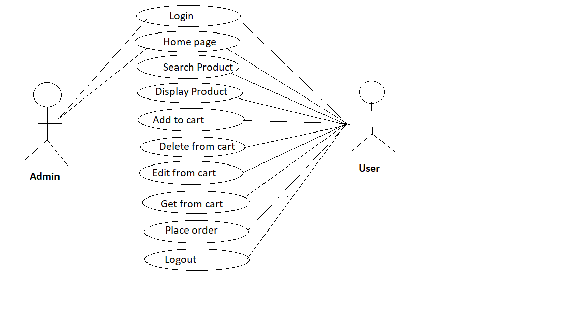

**Specification of Use Cases:**

**Use Case Login**

|  |  |
| --- | --- |
| **Login** | |
| **Element** | **Login** |
| **Actor** | Admin/user |
| **Trigger** | With or without authentication |
| **Pre-Condition** | User has to enter login credentials |
| **Post Condition** | On clicking login user got to home page |
| **Normal Course** | 1.User enter to home page after login |

**Use Case Add Product**

|  |  |
| --- | --- |
| **Adding product** | |
| **Element** | **Add** |
| **Actor** | Admin |
| **Trigger** | With or without authentication |
| **Pre-Condition** | A button provided for adding product |
| **Post Condition** | On clicking products are added to page |
| **Normal Course** | 1.Use the product to add to page |

**Use Case Search Product**

|  |  |
| --- | --- |
| **Search Product with Category** | |
| **Element** | **Details** |
| **Actor** | User |
| **Trigger** | On clicking the search button after entering category name list of products in that category displayed. |
| **Pre-Condition** | A textbox provided for entering the category name |
| **Post Condition** | On clicking the search button products of that category are displayed in products page |
| **Normal Course** | 1.Use the category name to search the products |

**Use Case Search Product Details**

|  |  |
| --- | --- |
| **Search Product** | |
| **Element** | **Details** |
| **Actor** | User |
| **Trigger** | On clicking the search button after entering the product, list of products displayed |
| **Pre-Condition** | A textbox provided for entering the product name |
| **Post Condition** | On clicking the search button products are displayed |
| **Normal Course** | 1.User enters the product name |

**Use Case Display Product**

|  |  |
| --- | --- |
| **Display Products** | |
| **Element** | **Display** |
| **Actor** | User |
| **Trigger** | On clicking particular product, the information about the product is displayed. |
| **Pre-Condition** | User needs to click the image to get the details of product. |
| **Post Condition** | The information regarding product is displayed on the page. |
| **Normal Course** | 1.User clicks the image to get details. |

**Use Case Add to cart**

|  |  |
| --- | --- |
| **Adding product to cart** | |
| **Element** | **Add** |
| **Actor** | User |
| **Trigger** | When user wants to buy, user will add to cart and store it. |
| **Pre-Condition** | If the user likes a particular product, he can choose by clicking the add to cart. |
| **Post Condition** | Selected products are available in the cart. |
| **Normal Course** | 1.User selects the product and click add to cart button.  2. Selected product is adding into the cart |

**Use Case Delete From cart**

|  |  |
| --- | --- |
| **Adding product to cart** | |
| **Element** | **Delete** |
| **Actor** | User |
| **Trigger** | User deletes the product from cart if user not interested to buy. |
| **Pre-Condition** | User delete product from cart. |
| **Post Condition** | The products that are not available or expired products deleted from cart. |
| **Normal Course** | 1.Selected product is deleted from the cart |

**Use Case Edit Cart**

|  |  |
| --- | --- |
| **Edit cart** | |
| **Element** | **Edit** |
| **Actor** | User |
| **Trigger** | When the products need to be updated. |
| **Pre-Condition** | The quantity of product we ca update |
| **Post Condition** | On clicking the button selected products are updated from cart |
| **Normal Course** | 1.Selected product is updated with order from the cart |

**Use Case Get from Cart**

|  |  |
| --- | --- |
| **Getting products from cart** | |
| **Element** | **View cart** |
| **Actor** | User |
| **Trigger** | When user wants to check the products selected |
| **Pre-Condition** | A button provided for viewing products added to cart |
| **Post Condition** | On clicking the cart button products are displayed from cart |
| **Normal Course** | 1.All user selected products are displayed from the cart in page |

**Use Case Place Order**

|  |  |
| --- | --- |
| **Placing order** | |
| **Element** | **Place order** |
| **Actor** | User |
| **Trigger** | When user clicks on place order button. |
| **Pre-Condition** | A button provided for place order to order product |
| **Post Condition** | The User Places the order |
| **Normal Course** | 1.User clicks the place order button. |

**Use Case Logout**

|  |  |
| --- | --- |
| **Logout** | |
| **Element** | **logout** |
| **Actor** | user |
| **Trigger** | With or without authentication |
| **Pre-Condition** | A button provided for logout |
| **Post Condition** | On clicking logout button user logout from page |
| **Normal Course** | 1.User logout from page |

**Database Table Designs:**

**Product Category:**

|  |  |  |
| --- | --- | --- |
| **Field Name** | **Type** | **Remark** |
| CategoryId | int | PK |
| CategoryName | Varchar (50) |  |

**Product:**

|  |  |  |
| --- | --- | --- |
| **Field Name** | **Type** | **Remark** |
| CategoryId | int | FK |
| ProductId | int | PK |
| ProductName | Varchar (50) |  |
| Picture | Varchar (50) |  |
| Price | int |  |
| Color | Varchar (50) |  |
| Brand | Varchar (100) |  |

**CartItems:**

|  |  |  |
| --- | --- | --- |
| **FieldName** | **Type** | **Remarks** |
| ProductId | int | FK |
| ProductName | Varchar (50) |  |
| Picture | Varchar (50) |  |
| Price | int |  |
| Brand | Varchar (100) |  |

**Login:**

|  |  |
| --- | --- |
| **Field Name** | **Type** |
| username | string |
| password | string |

**APPENDICES:**

**Login page:**

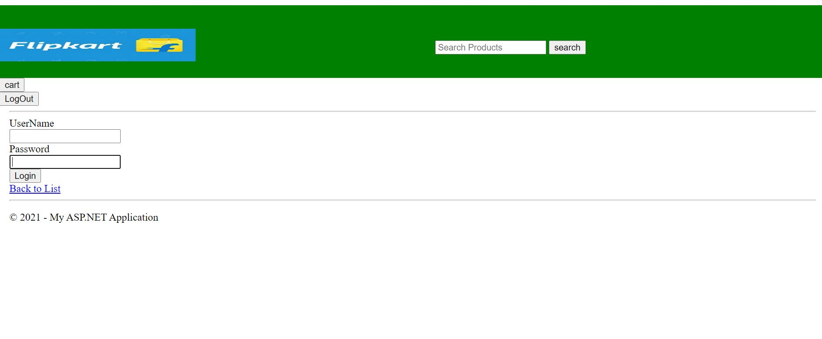

**Home Page**

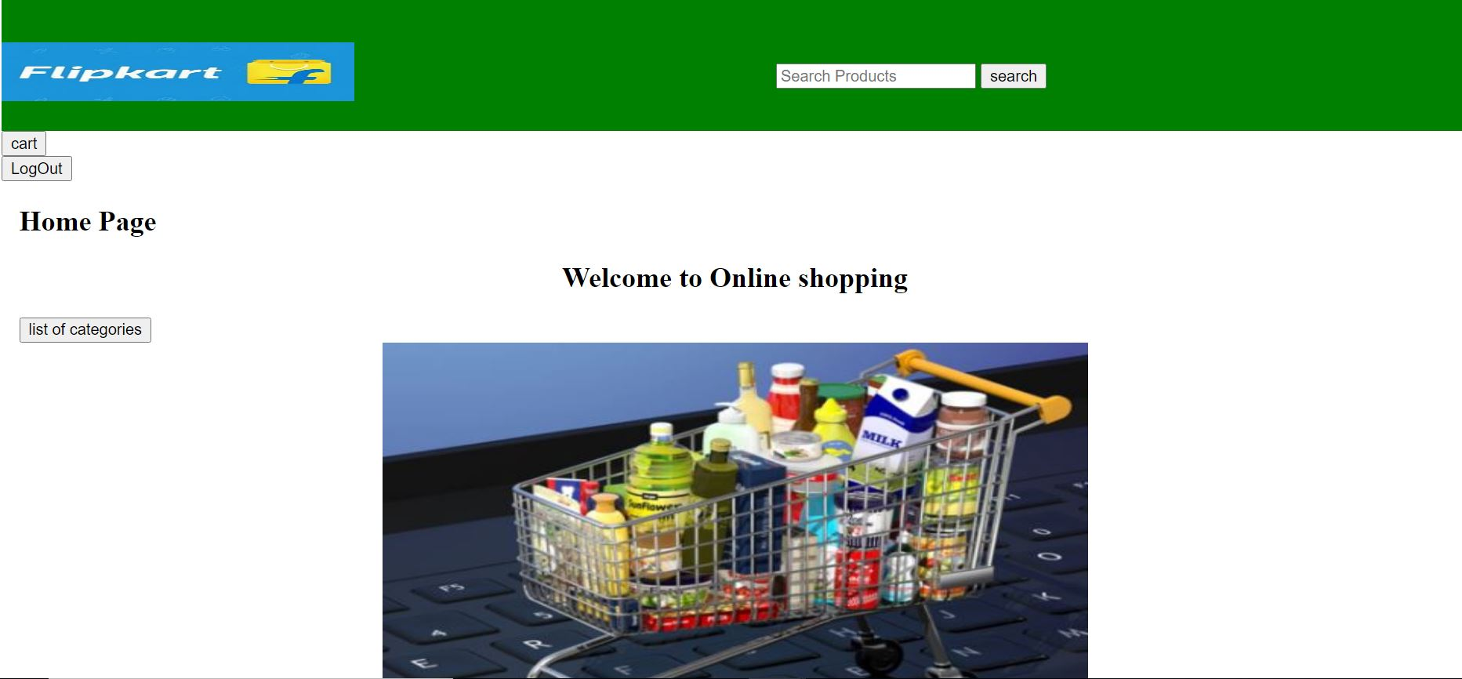

**Product**

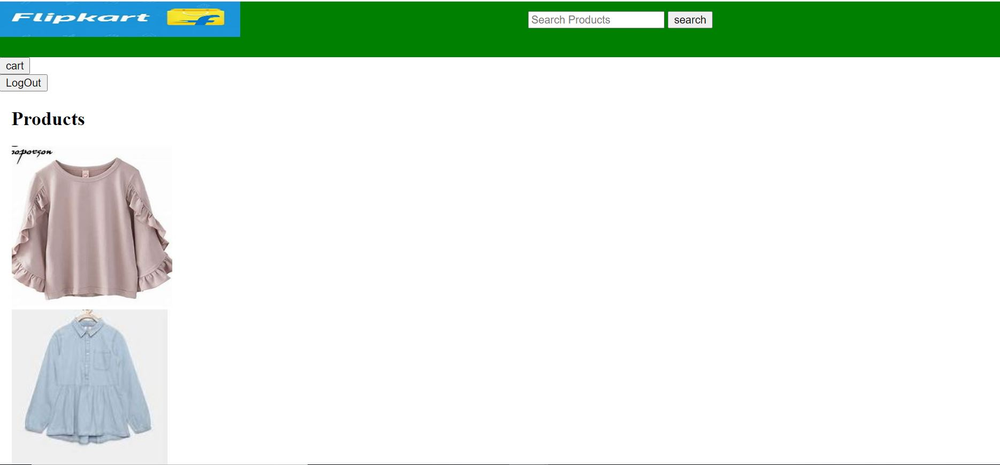

**Product Details**

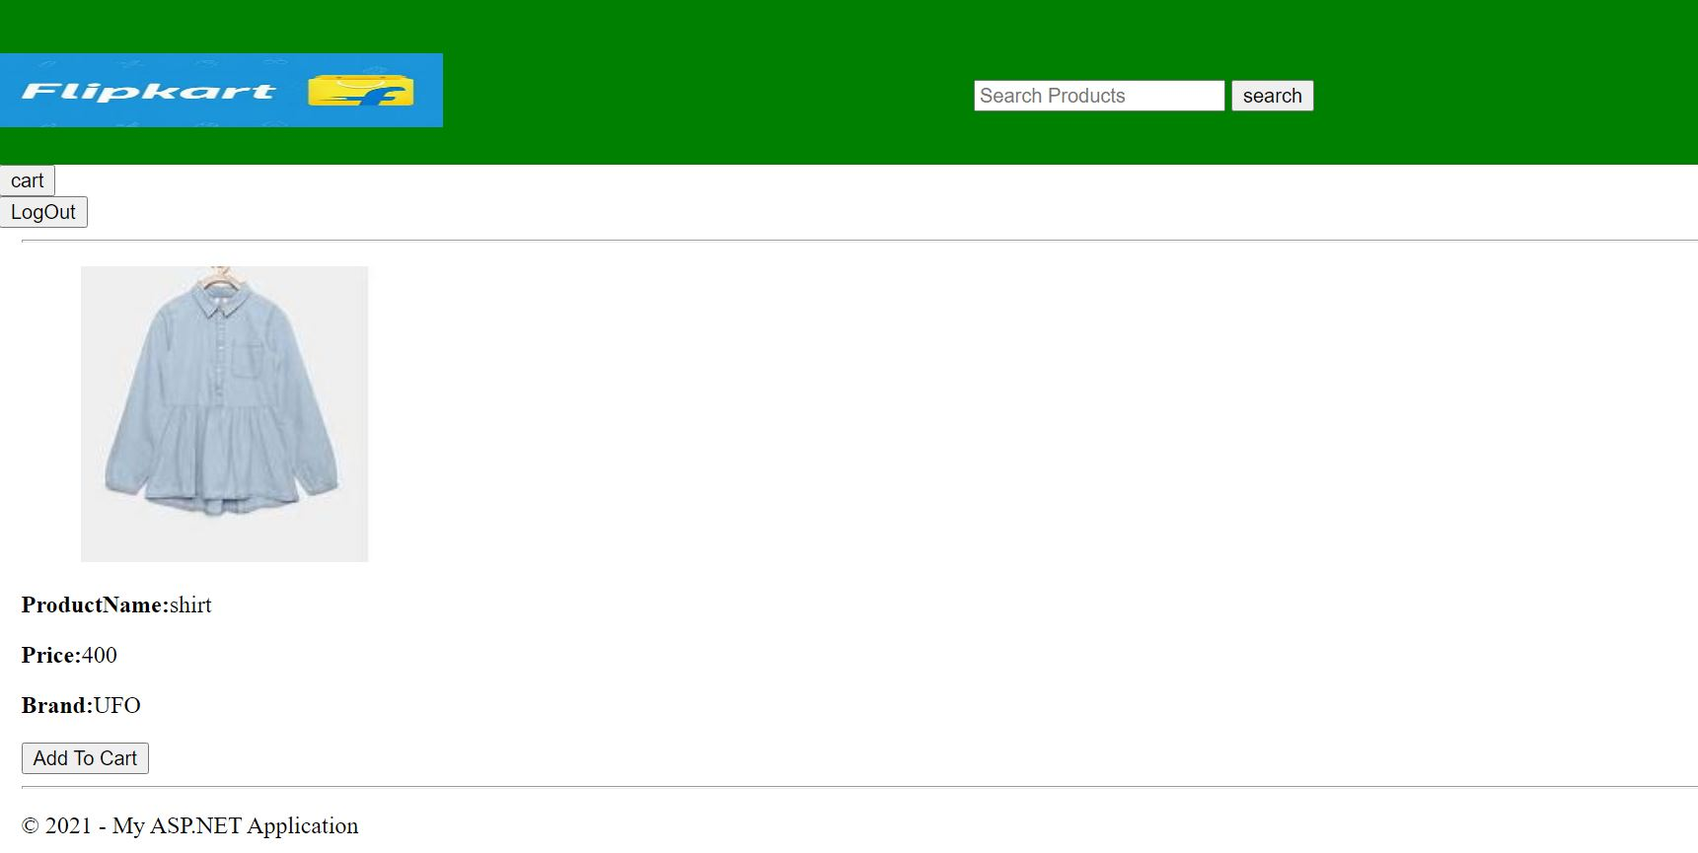

**Display Cart**

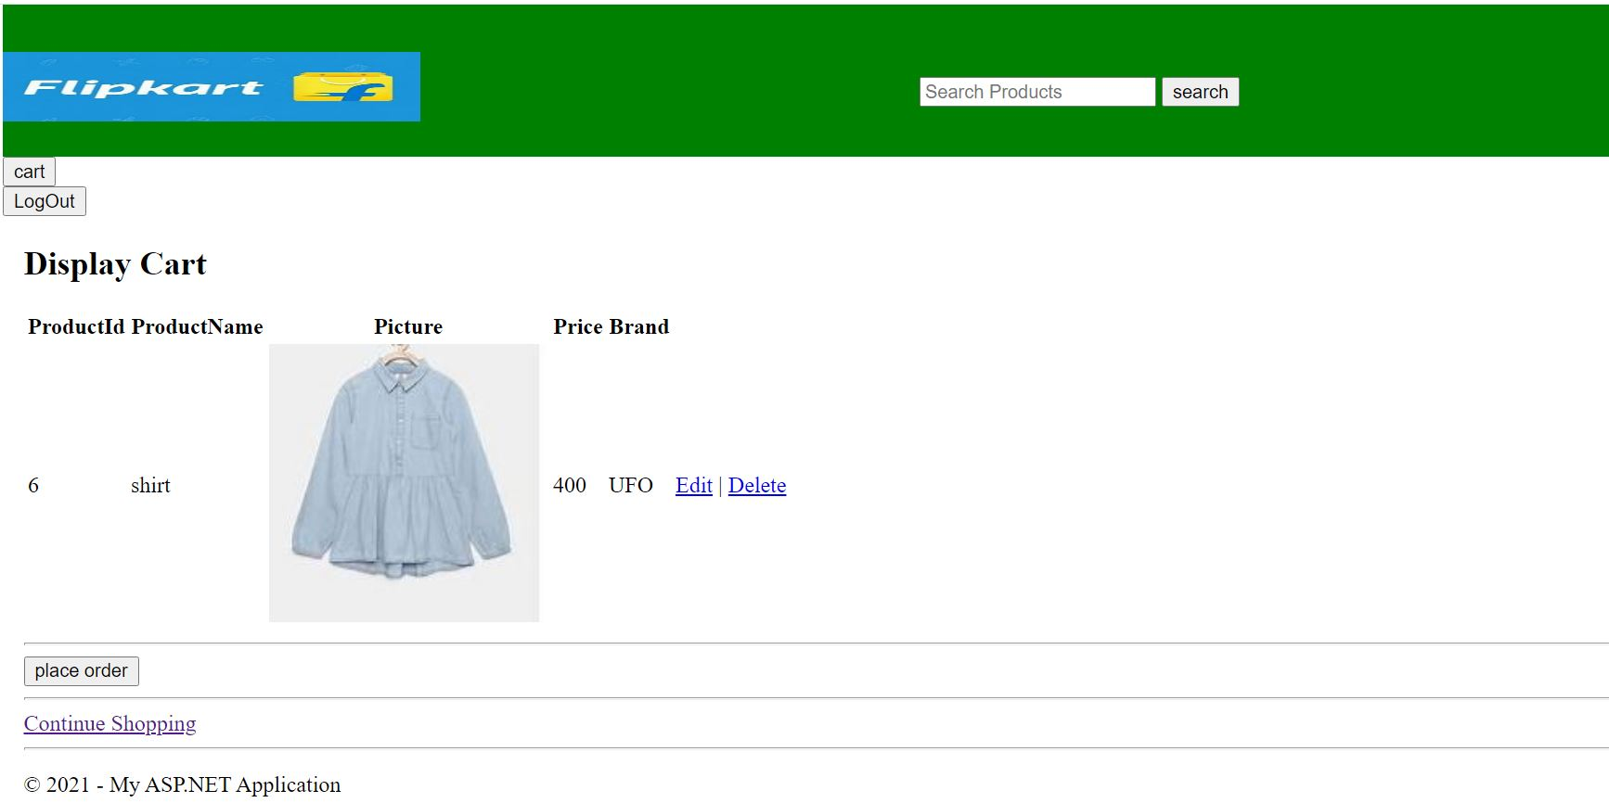

**Get from Cart**

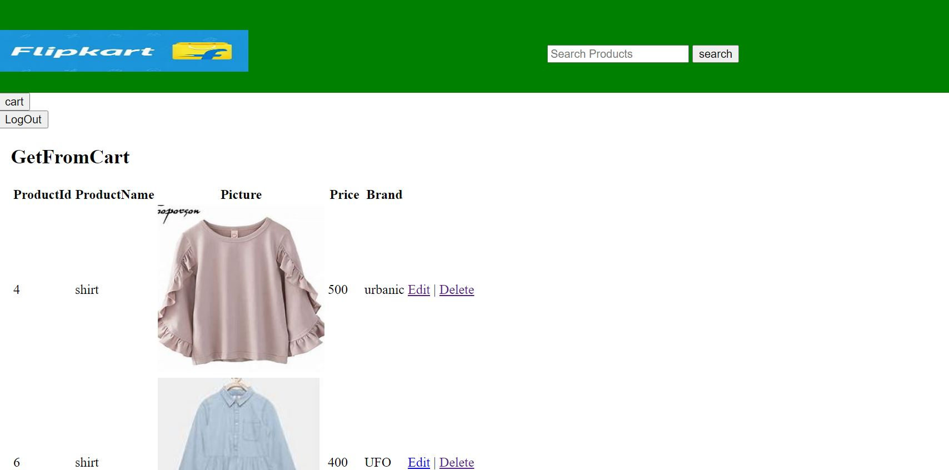

**Place Order**

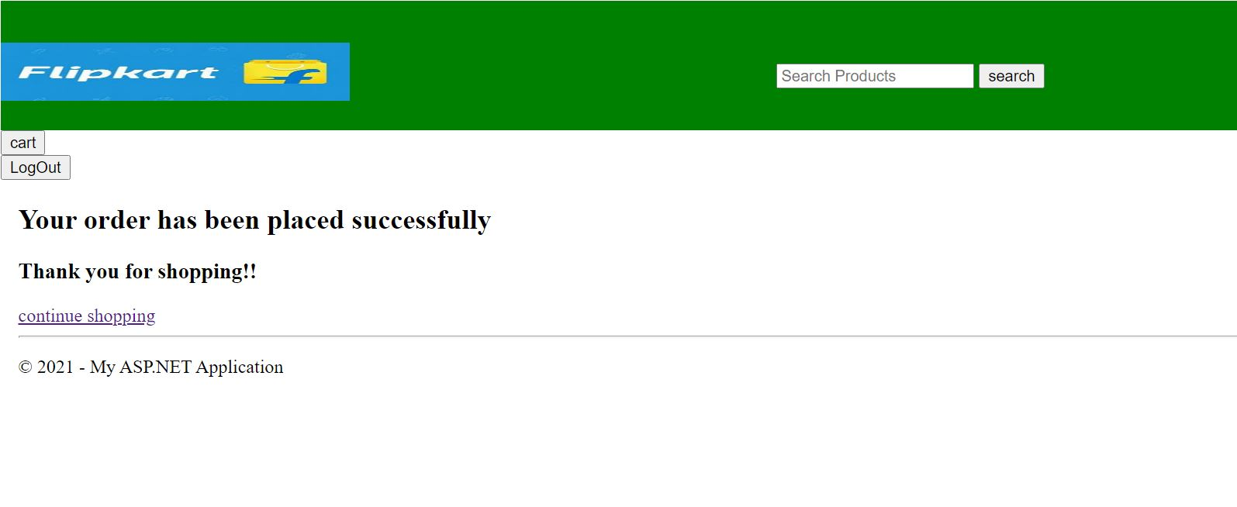

**Logout:**

